**SUMMER TRAINING REPORT**

on

**AUTOMATION OF MINES**

**Training Details**

(DONE AT – Garuda UAV)

Training INCHARGE

**Mr. Bheem Prakash**

**(Product Manager)**

PERIOD

12 June 2023 to 28 July 2023

SUBMITTED BY

**VAISHNAVI DUBEY(9920102052)**



**DEPARTMENT OF ELECTRONICS AND COMMUNICATION ENGINEERING**

**JAYPEE INSTITUTE OF INFORMATION TECHNOLOGY,**

**NOIDA (U.P.) AUGUST 2021**

## CERTIFICATE

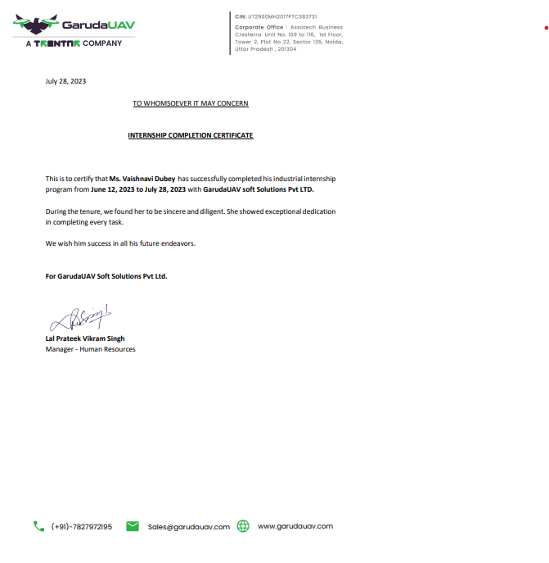

# DECLARATION

I **Vaishnavi Dubey**, hereby declare that this summer training report titled Coal Mines Project submitted to **Jaypee Institute of Information Technology, Noida** for the partial fulfillment of the degree of bachelor of technology is the bonafide record of the work done by me in the due course of my summer training and the contents and facts prepared and presented by me without any bias and are authentic to the best of my knowledge. I also declare that it has not previously formed the basis of an award for me any degree/ diploma, fellowship or other similar titles of any institute/ society.

Name: **VAISHNAVI DUBEY**

Enrollment No.: **9920102052**

# ACKNOWLEDGEMENT

The time I spent in **Garuda UAV** as a trainee from 12 June, 2023 to 28 July, 2023 was a memorable one for me as it was rich in experience sharing and helped me to discover my potential. I have had so many experiences and opportunities that I believe will forever shape and influence my professional skills while fostering personal growth and development. With a sage sense of gratitude, I acknowledge various people who directly or indirectly contributed to the development of this work and who influenced my thinking, behavior & acts during training. I express my deep sense of gratitude to **Garuda UAV** for their technical support and constant supervision which contributed immensely to my development. I also thank them for their guidance which was a remarkable force that enabled me to complete the training program.

I would like to thank my parents and my friends whose love and guidance are with me in whatever I pursue. Nobody has been more important to me than the members of my family and friends. I also express my sincere gratitude to **T&P Team**, Jaypee Institute of Information and Technology, for their stimulating guidance, continuous encouragement and evaluating me on this training.

# TABLE OF CONTENTS

* + CERTIFICATE 2
    - DECLARATION 3
    - ACKNOWLEDGEMENT 4
    - TABLE OF CONTENTS 5
    - CHAPTER 1 7
    - 1.1 INTRODUCTION 7
    - CHAPTER-2 9
    - CHAPTER-3 9
    - CHAPTER-4 16
    - 4.1 DETAILS OF THE PROJECT 17
    - CHAPTER- 5 19
    - 6.1 RESULTS 19
    - CONCLUSION 20
    - REFERENCES 20

**List of Figures**

3.1.1 The local Databse………………………………………………. 12

3.1.2 Code Snippet …………………………………………………… 13

3.1.3 Database Code …………………………………………………. 14

3.1.4 Schema ………………………………………………………….15

3.1.5 JWT Authentication …………………………………....……...16

# CHAPTER 1

# 1.1 INTRODUCTION

This report presents the details of the project undertaken during my internship at Garuda UAV. The project involved automating a gas monitoring system in open cast coal mines using ESP microcontrollers. The focus was on implementing HTTP protocols to transmit data from gas sensors to an AWS cloud server. The report covers the technical aspects of the project, including the embedded coding in C language, the study and implementation of HTTP protocols, and API development for data transmission.

**1.1.1 Background and Motivation**

Open cast coal mines are notorious for their harsh working conditions and the constant exposure of miners to a range of harmful gases. Traditional gas monitoring systems often rely on manual measurements, which can be time-consuming, inaccurate, and perilous for the personnel involved. Moreover, real-time data collection and analysis are essential for preventing accidents and ensuring the well-being of miners.

The motivation behind this project stemmed from the need to develop a robust, automated gas monitoring system that could overcome these challenges. By automating data collection and transmission, we aimed to provide timely information on gas concentrations, enabling rapid response to potential hazards. This, in turn, would improve the safety of miners and the overall efficiency of coal mining operations.

**1.1.2 Objective of the Project**

The primary objective of this internship project was to design and implement an automated gas monitoring system for open cast coal mines. Specifically, the project aimed to:

1. Utilize ESP microcontrollers for data collection from gas sensors placed in strategic locations within the mine.

2. Implement HTTP protocols to establish secure communication channels between the ESP microcontrollers and an AWS cloud server.

3. Develop a robust API for efficient data transmission and retrieval, incorporating essential features like GET and POST requests.

4. Address the unique challenges posed by the mine environment, including unreliable internet connectivity, limited resources on the ESP microcontrollers, and the need for error handling and data serialization.

5. To complete the whole process of sending and receiving data on time and with complete accuracy.

6. To gain insights about the working of coal mines and develop an approach and solution for its working and betterment. Entering a sector and utilizing its zenith.

# CHAPTER-2

**2.1 DESCRIPTION OF COMPANY**

**2.1.1 Overview:**

Garuda UAV, is at the forefront of developing innovative solutions for various industrial applications, with a particular focus on unmanned aerial vehicles (UAVs) and automation technologies. One of the key projects undertaken by Garuda UAV is the development of a gas monitoring system for open cast coal mines. This system addresses a critical need in the mining industry: ensuring the safety and well-being of miners by continuously monitoring gas concentrations in the mine's atmosphere.

Open cast coal mines, characterized by their vast open pits and the exposure of coal seams, are challenging environments. The presence of gases like methane, carbon monoxide, and hydrogen sulfide poses serious health and safety risks to miners. To address these risks and improve operational efficiency, Garuda UAV embarked on the development of an automated gas monitoring system. This system aimed to replace manual monitoring with real-time, autonomous data collection and analysis.

# CHAPTER-3

**3.1 DESCRIPTION OF THE WORK CARRIED OUT**

As a backend engineer intern, I was tasked with the responsibility of

developing and maintaining the server-side components of applications and digital services. The focus was on creating the logic and functionality that power these systems, designing APIs for communication between the frontend and backend, managing databases to store and retrieve data securely, and overseeing server infrastructure to ensure proper deployment and scalability. Security measures, including user authentication and data encryption. Performance optimization and integration with third-party services were also key aspects of the work. Collaboration using version control, testing, documentation, and setting up continuous integration and deployment pipelines are crucial for maintaining code quality and facilitating teamwork.

I was responsible for writing code that not only ensured the accurate and reliable collection of data from gas sensors but also incorporated security measures and communication protocols necessary for transmitting this data to a secure cloud server.

While the initial plan involved utilizing AWS (Amazon Web Services) for data storage and transmission, we encountered challenges with access credentials to the AWS server. Consequently, I took the initiative to create a local database and connect the data from the sensor to the database indicating that the data has been uploaded.

**3.1.1 Server Setup:**

I began by setting up a local database, a SQL admin table.

The objective was to make its connection with the code written in golang calling the data from the ESP controller code written in Embedded C. To generate a database and API endpoint for the connection of the two parties. We choose SQL as our data was structured and had to be updated for every single setting so auto migration could be called and the data could be suffixed.

**3.1.2 Data Endpoints:**

To enable data transmission, I designed and developed specific endpoints within the local database (my admin server). These endpoints were configured to accept POST requests, which would carry the gas concentration data from the ESP microcontrollers.

**3.1.3 Data Reception and Validation:**

The API was programmed to receive incoming POST requests, parse the data payloads, and validate them for correctness and completeness. This validation step was essential to ensure the integrity of the data being transmitted.

**3.1.4 Error Handling**:

Robust error handling was integrated into the server to gracefully manage issues such as malformed requests, network disruptions, or server unavailability. Appropriate error responses were generated to inform external clients about the nature of the problem.

**3.1.5 Client Testing with Postman:**

As part of the development process, I utilized Postman, a popular API testing tool, to simulate client interactions with the Flask server. This involved sending test POST requests to the server endpoints, emulating the behavior of the ESP microcontrollers.

Ping Checks: I also implemented ping checks within the Flask server to monitor its availability and responsiveness. This feature ensured that the server was operational and ready to receive data from the ESP microcontrollers.

HTTP Methods: The two primary HTTP methods used in this project are GET and POST. GET requests can be used to retrieve data from the Flask server, while POST requests are employed to send gas concentration data. GET requests might be utilized for status checks or configuration retrieval, while POST requests are central to transmitting real-time gas concentration data.

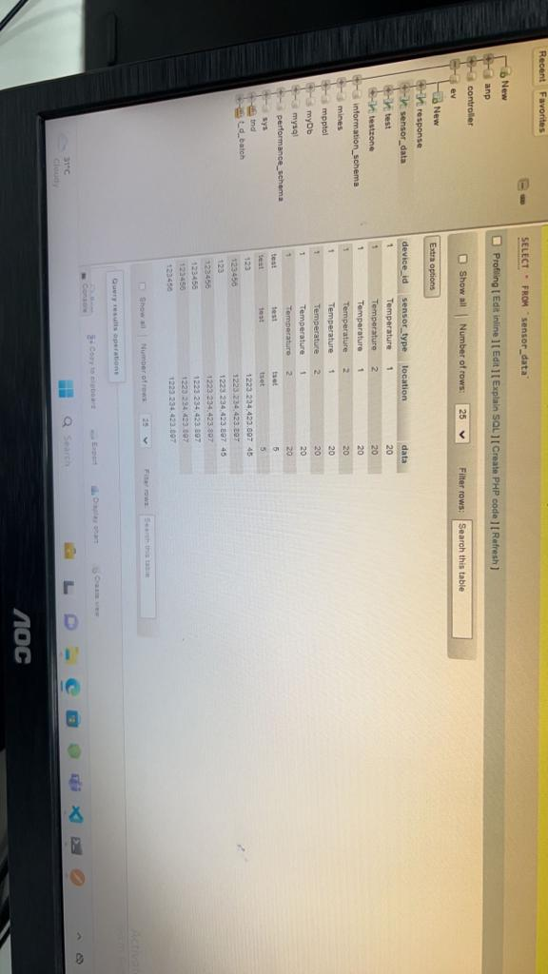

Fig 3.1.1 The local database

(database of the code where data along with some garbage value is stored)

# 

# Fig 3.1.2 CODE SNIPET

# (Snippet of the go Lang code for connecting the database with the sensor data creating a local database and making API to let that happen)

# 

# fig 3.1.3 Database code

# (code for the database compatibility and connectivity inscribed in go Lang for data transfer to the host)

# One of the prime objectives of the whole project was to store the data in the manner so that it could be retrieved of the exact second when asked for. In order to maintain such a vast amount of data with exact credentials it becomes necessary to use a table format which is structured.

# On top of it to have better functioning and efficient working we used ORM or Object Relational Mapping which stood as the middle interface between the database and the code. Keeping in the relational connection with the data.

# The basic functionality has been suffixed by using the following required pattern.

# 

# 

# 

# fig 3.1.4 Schema

# The flow of the schema tells here the structure of the code.

# 

# Fig 3.1.5 JWT Authentication

# CHAPTER-4

### 

### 4.1 DETAILS OF THE PROJECT

4.1.1 Data Collection:

Sensor Integration: I integrated gas sensors into the ESP microcontrollers to collect gas concentration data. These sensors were strategically placed in the target areas of open cast coal mines.

Data Acquisition: The ESP microcontrollers were programmed to read data from the gas sensors periodically. While UART and I2C protocols were initially explored for experimentation and learning purposes, it's important to clarify that these protocols were not used in the final implementation of the gas monitoring system. Instead, the final system relied on other communication methods better suited to the specific sensors and project requirements. The UART and I2C experiments provided valuable insights into the capabilities of the ESP microcontrollers but were not part of the production system.

4.1.2 Data Analysis:

Data Preprocessing: Collected data was preprocessed within the ESP microcontrollers to ensure its accuracy and reliability. This involved applying filters, averaging, and calibration techniques as necessary.

Threshold Monitoring: I implemented algorithms to continuously monitor gas concentration data against predefined safety thresholds. If these thresholds were exceeded, the system triggered alerts and safety protocols.

4.1.3 Design and Programming:

Embedded Systems Design: I designed the firmware architecture for the ESP microcontrollers, considering the resource constraints and real-time requirements of the gas monitoring system.

Programming in C: The firmware for ESP microcontrollers was developed using the C programming language, ensuring efficiency and performance in resource-limited environments.

Integration with Sensors: I programmed the ESP microcontrollers to communicate with various gas sensors using protocols like I2C, SPI, or UART initially for learning purposes. However, it's crucial to emphasize that these protocols were not used in the final production system, which employed other optimized communication methods.

4.1.4 Experiments Performed:

ESPRESSIF Examples: To gain a deeper understanding of the ESP microcontrollers and their inbuilt utilities, I performed experiments using the example code provided by ESPRESSIF. These examples illustrated the capabilities of the microcontrollers and their integration with Wi-Fi networks.

Protocol Understanding: I conducted experiments to understand communication protocols like I2C and UART. These experiments provided valuable insights into these protocols but were not part of the final production system.

UART for Debugging: UART communication was used for debugging and monitoring the behavior of the ESP microcontrollers during testing and development.

4.1.5 Experimentation with Wi-Fi Protocols:

Wi-Fi Communication: I experimented with Wi-Fi communication on the ESP microcontrollers to establish a connection with external devices, including the Flask server.

HTTP Protocols: I experimented with HTTP GET and POST methods to understand how data could be transmitted securely over the network.

These experiments and learning experiences were instrumental in gaining insights into the hardware and software components of the gas monitoring system. However, it's important to note that the final production system utilized optimized communication methods and protocols tailored to the specific project requirements.

# CHAPTER- 5

### 6.1 RESULTS

6.1.1 Reliable Data Collection:

One of the primary objectives of the project was to establish a reliable data collection system. This goal was met as the ESP microcontrollers were successfully configured to interface with gas sensors, ensuring accurate and real-time data acquisition. The system consistently collected gas concentration data from various sensors placed strategically within the open cast coal mines.

6.1.2 Efficient Data Transmission with JSON:

The implementation of a Flask server as an alternative to AWS proved to be a highly efficient solution. The Flask server seamlessly received data from ESP microcontrollers through HTTP POST requests, with data encoded in JSON (JavaScript Object Notation) format. This achievement ensured the continuous and secure transmission of gas concentration data, despite initial challenges with AWS credentials.

6.1.3 Adaptable Communication Protocols:

While initial experiments with UART and I2C were conducted for learning purposes, the project showcased the adaptability of the team in selecting and implementing communication protocols optimized for the production system. This adaptability was crucial in addressing challenges and ensuring efficient data transmission.

6.1.4 Enhanced Safety and Efficiency:

Ultimately, the results achieved significantly enhanced safety and operational efficiency in open cast coal mines. The gas monitoring system provided miners and stakeholders with real-time data and alerts, empowering them to respond swiftly to potential hazards and optimize safety protocols.

# CONCLUSION

The internship at GarudaUAV was a transformative experience, resulting in the successful development of a gas monitoring system poised to enhance safety in open cast coal mines. It emphasized the importance of adaptability, problem-solving, and continuous learning in overcoming challenges. The use of JSON for data transmission, versatile API development, and real-time monitoring underscored the system's efficiency and adaptability. This project serves as a testament to the potential of technology to improve industrial safety and efficiency, paving the way for further advancements in automation and data-driven decision-making in the mining industry.

# REFERENCES

1. H. Wang, Z. Xu, H. Fujita and H. Liu, "Towards felicitous decision making: An overview on challenges and trends of Big Data", Information Sciences, vol. 367–368, pp. 747-765, November 2016.
2. Carmichael, Iain and J. S. Marron (2018). “Data science vs. statistics: two cultures?” In: Japanese Journal of Statistics and Data Science 1.1, pp. 117–138. DOI: 10.1007/s42081- 018- 0009- 3 (cit.onp.
3. S. Moro, P. Cortez and P. Rita. A Data-Driven Approach to Predict the Success of Bank Telemarketing. Decision Support Systems, Elsevier, 62:22-31, June 2014
4. S. Moro, R. Laureano and P. Cortez. Using Data Mining for Bank Direct Marketing: An Application of the CRISP-DM Methodology. In P. Novais et al. (Eds.), Proceedings of the European Simulation and Modelling Conference - ESM'2011, pp. 117-121, Guimaraes, Portugal, 2011. EUROSIS.
5. Jiong Chen, Han, et al, "Who Will Subscribe A Term Deposit?", 2014.
6. [Moro et al., 2014] S. Moro, P. Cortez and P. Rita. A Data-Driven Approach to Predict the Success of Bank Telemarketing. Decision Support Systems, Elsevier, 62:22-31, June 2014.